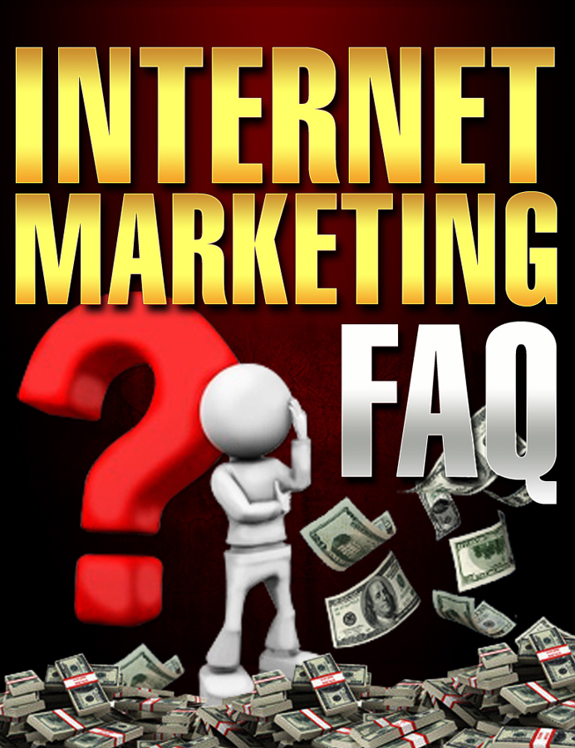

LEGAL NOTICE
The Publisher has strived to be as accurate and complete as possible in the creation of this publication, notwithstanding the fact that he does not warrant or represent at any time that the contents within are accurate due to the rapidly changing nature of the Internet.

In practical advice books, like anything else in life, there are no guarantees of income made. Readers are cautioned to reply on their own judgment about their individual circumstances to act accordingly.

This book is not intended for use as a source of legal, business, accounting or financial advice. All readers are advised to seek services of competent professionals in legal, business, accounting, and finance field.

Perceived slights of specific people or organizations are unintentional.
You are encouraged to print this book.

Get Your Free Bonuses Here . . .
To say “Thanks” for taking the time to read this guide, I’ve put together a special page full of free bonuses for you. These are all great resources, and can all help your business in some way.
Have a look at the following page, and get the bonuses that can help you with your business . . .
www.GetYourFreeBonuses.com

QUESTION:

It seems that 5% of the people in internet marketing make 95% of the money. Why do so many people fail and what are the big dogs doing that the rest aren’t?

ANSWER:

First define internet marketing – it's actually not just about marketing online, it actually consists of 3 groups of people
    - Consumers – accomplishment is in the purchase
    - Business opportunity seekers (quasi business people) shotgun approach try to do everything. They chase lots of different programs and don't focus on anything
    - Entrepreneurs who are using the internet as one of their marketing vehicles or maybe their main. They're focused on their business. They understand business.

People who are not making it are generally in the first two categories

  - 20 / 80 rule 20% of the people make 80% of the money
  - the same people that make the money in the internet marketing industry would make money in any industry whether it's real estate, investing, or pottery
The reason is they follow 4 simple disciplines

  - mindset – focus – education – action

The way you think defines your reality. It defines what you get out of life.
What you believe you can achieve

Your thoughts can make you healthy and your thoughts can make you wealthy

Henry Ford: There's 2 kinds of people in this world – those that think they
can and those that think they can't – they're both right

Donald Trump: If you're going to be thinking anyway, think big

Look at the way these people think. And look at their achievements. There's a direct correlation there. There's a direct link between the way you think and what you actually get.

Without getting into a whole belief system, if you look at your business as a mickey mouse operation, you'll make a mickey mouse income. If you look at it as a multinational corporation, your income will follow.

Doesn't matter if you're working in the corner of your bedroom. It's your mindset that makes the difference.

The other part of the equation is action. Because you can sit stagnant in a corner all day long thinking I'm going to be successful, but without action to back it up, nothing will happen.

Mindset is absolutely critical.

The next step is your focus
This is where you really need to discipline yourself

-proactive instead of reactive – we'll cover the difference in a moment

know where your business is going. What do you want out of it short term, what do you want out of it long term. What's your exit strategy.

Exit strategy:
- Work it for the rest of your life
- work it for 5 years and sell it
- work it for 5 years and then take it public and sit as a chairman

By knowing where your business is going you can set up your objectives, strategies and tactics

Objectives are: What are you going to do
Strategies are: How are you going to do it
Tactics are: What are you going to do on a daily basis to meet your goals

Objective: Operate a website that sells resale rights ebooks and software and generates an income of $100,000 a year

Strategies: Buy all the resale rights products on the market and develop the most comprehensive, organized, valuable resale rights website on the internet.

Market your website using SEO, article writing and teleseminars that you podcast

Tactics: Optimize each webpage you design
Write 3 articles each week and post them to article directories
Conduct 2 teleseminars and podcast them every week

Objective is the high level overview
Strategies are a focused version of your objectives
Tactics are your daily ToDo list

Once you've got that under your belt, we can go back and talk about proactive and reactive

Proactive is deciding how your business is going to run and then going out looking for products and services that are going to help you leverage your money and your time to maximize the effectiveness of your business.

Reactive is when you have no idea of what you want in a business. You turn on your computer and everything looks great. You buy a search engine optimization book, you buy the newest book on blogging, you join a couple network marketing companies, and you order a 57 set DVD home study course on starting your home business.

You're all over the board because you have no focus, so you spend tons of money, never follow through on what you buy. Your hard drive is cluttered with stuff, but you never take the time to learn it.

The next point Education

You have to educate yourself. But you need to focus on getting educated in the areas where you need expertise or at least hire people in the areas that you're going to focus your business on.

The challenge people have online is they turn on their computer, hop online and think they should be pulling in hundreds or thousands of dollars tomorrow, without having the first clue about what they're doing. Then they get disgruntled because nothing works and they quit thinking the internet is just a scam

It's like me waking up this morning and deciding I'm going to be a brain surgeon. So I rent an office, get some tools, and set a sign outside my door that says Terry Telford Brain surgeon.

First of all, I know nothing about what I'm doing, no one shows up to my office and I feel sorry for them if they did. So I get frustrated and think brain surgery is a scam and I close my office and bury my head in the sand.

The final discipline is taking action

That one is self-explanatory. You put things into motion. Be as effective as you can. And don't be afraid to outsource some of the parts of your business you don’t have to directly do.

So I guess that's the long way around the block, but that basically covers the differences between the 20% that make the 80% of the money and the other 80% that never seem to get it.

QUESTION

Every week there’s a new money making method. How do we know what to follow and what to leave behind?

ANSWER

That goes back to your focus. When you know where you're going all these get rich quick schemes don't appeal to you. Because you know exactly what you need to be focusing on to achieve your goals.

So if your main focus for your business is doing voice overs and interviews and I come to you and say Scott I've got a great new juice that gives you massive energy and we can work this thing together with this network marketing plan that's going to make us rich. With your business focus being on doing interviews and voice overs what are you going to tell me?

But if your focus is I've got to find a way to make money online. It doesn't matter what it is I've just got to make money. Then the juice deal looks great.

It all comes back to knowing why you're in business and what you're in business to do.

QUESTION

Many people say to create your own product for your online business, then many people say not to. What should we be doing?

ANSWER

Someone who comes online with no product and no business experience should first off become an affiliate. There's no point in creating a product first because it takes too long. They could be using the time to learn how to market. And develop a marketing system that they're good at. Because the marketing skills you learn as an affiliate are easily transferable to your business when you develop your own product.

So the marketing system you set up is already in place when you develop your first product. And once you've got an affiliate income, it makes it much more comfortable to take a month or a couple months to develop your own product.

So yes, you definitely want your own product because you make more money, then you have affiliates selling your product for you, your reach is much greater and your profit levels are higher.

QUESTION

Since information overload is an everyday fact of life, how do we know what to focus on and what to ignore?

ANSWER

Information overload is often caused by not having a focus. And I know I keep coming back to this point, but it's so critical to your business success is having a focus. So if you're focused, you filter out what you don't need to know.

There are literally thousands of ezines out there. And if you try and read them all, you'll be stuck in information overload, but if you pick 3 that focus on what you need to know to grow your business, then that's all you need to read.

So if I know that my online business needs a website. Website needs graphics, needs copy, needs programming. I have a choice I can either learn the skills myself to do that or I can hire someone to do it for me. So my focus is on building my website and that's the only thing I'm concentrating on so if someone sends me information on a juice company I'm not distracted. Because that has nothing to do with my website.

QUESTION

What is the most important part of an internet business?

ANSWER

An internet business is basically an electronic direct mail company. The components of running the business are the same. In fact, I used to own a direct mail company back in the late 90's and my big AHA moment or my epiphany about my online business came when I realized that my business online had the same structure as my offline mail order business.

The reason I'm telling you that is to tell you this. The most important asset of any direct mail business online or offline is your database. In internet marketing people like to call it your list. Call it what you want, your database is the jewel in the crown.

QUESTION

What are the characteristics of a successful internet marketer?

ANSWER

I've interviewed a lot of entrepreneurs in the past 6 years and all the successful ones share a common belief. It's the "Can Do" attitude. It doesn't matter what's going on around them, who says it can't be done, who says it can, they put on the blinders and do it. They make it happen.

Now along the way, we all pick up skills we need to develop to deal with different aspects of our businesses. As you grow and develop and learn more about how to do business and you start experiencing success, you develop your self confidence. You become more comfortable having intelligent conversations with other people in your industry.

You learn to set goals. And then you learn how to achieve them. Just thinking I'd like to make a million dollars this year isn't going to do it. You need a plan. You need to plan your work and work your plan. I love expressions ☺

And you have to learn how to guard your time. You have to be ruthless with your time management. I set a schedule for myself so my day is broken up into blocks.
- I answer my email first thing in the morning until 10am. If I'm not done by 10, the rest waits until the next day. I'm in internet marketing not in fire fighting, so there's no emergency that can't wait until tomorrow.
- Next I spend 2 hours on my marketing. At 12 I stop for lunch for 30 minutes. I read during my lunch and then I read until 1pm
- From 1pm-4pm I work on projects
- From 8pm – midnight I work more on projects and tie up loose ends

Time is more valuable than money. It's the only thing all human beings share. None of us has more or less hours in a day. And you can never get back an hour you waste. My biggest pet peeve is to hear someone say "I'm just killing time." I have nothing to do so I'm just hanging out killing time. What a waste of a life.

QUESTION

It seems that all the 6 figure marketers have their own networks that support them. How important is developing relationships to success? How can you develop these?

ANSWER

Up until September 2007, I never left my office. I spent 6 years in my office meeting people online, but never face to face. Then I did a trial by fire. I attended 2 internet marketing seminars in a row. One at the end of September and one the first week of October. And it changed my business.

Working in my office, I send out an email, I do my marketing and I make sales, so I know people are reading my mail and my marketing is working, but I don’t know what people think of me. When I went to these conferences I had people walking up to me saying hey are you Terry Telford? I had no idea anyone knew who I was. When I introduced myself to some of the big name marketers they knew who I was. And it changed my perspective on my business and on myself because I suddenly felt more responsible for my business.

The easiest way to develop a network is start attending some of the internet marketing seminars and get out there and meet people. I've never worked in a more friendly industry than internet marketing. Everyone is happy to meet you and network with you.

It's funny because one of the conferences I was at was running beside a bricks and mortars business conference and in the lobby you could tell who the internet marketers were and who the other guys were because we're all happy and smiles and jovial and feeling great and the other conference looked like it was a funeral. They were all sombre and straight faced. No fun at all.

QUESTION

There's lots of business models online, can you tell us why it's important to follow just one? And avoid jumping from program to program?

ANSWER

Oh wow yeah. You really hit the nail on the head there. It's kind of like information overload. The way to avoid it is to develop your focus. Choose a business model that you're comfortable and works for you and then follow it.

The typical internet marketing business model today was really pioneered and honed by Mike Filsaime and it's what he based his butterfly marketing software on.

Basically, you give something away for free in exchange for people signing up to your database, then you offer them a one time offer for one of your products, if they say no you offer them a second one time offer that can be a lite version of the OTO you just offered them and if they say no again, they go to the membership website where they login and collect their free gift.

At the same time, they're automatically entered into your affiliate program so they are incentivised to promote for you because they make a commission anytime someone they send to your website, buys the OTO.

And that system works wonderfully. That's why you see it all over the place.

But more important than what system you choose is choosing a system and working it.

QUESTION

What can we do to make sure our products are a success?

ANSWER

First, follow your heart. Look at what you are passionate about, what you love doing and follow that. Develop a product around what you love doing. And don't worry about whether it's going to sell or not. Don't think about the money. Think about the process.

If my passion is radio-controlled cars, I know everything about radio-controlled cars. I eat breath and live radio controlled cars. My first product may be to write an ebook on radio controlled cars or make a video on them or start a podcast radio station about them. It makes no difference what the subject is. It's the learning process.

You learn how to write an ebook. How to format it, how to turn it into a PDF, how to put pictures in it, how to turn that ebook into a print book. You learn everything about it.

If you're creating a video, you learn how to operate a video camera, you learn about green screens, you learn how to upload your video onto your computer and how to get it on the internet and how to post it on YouTube. You learn how to do video.

And then you learn how to get your product onto a website and you plug it into your marketing system and see if it flies. And you know what? Who cares if it flies or not. You know how to do things for your next product.

Then you can start visiting forums and see what people are asking about and you can either develop a whole new product or you can revamp your original one and come out with version 2 if version 1 did happen to be e hit.

QUESTION

Why is it important to get a good sales letter?

ANSWER

Your sales letter is a make or break point for your whole business. If you're sales letter doesn't explain the benefits of your product or service in a way that excites your market and pushes their hot buttons to make them want to buy your product, you're dead in the water.

You could have the world's best mouse trap, but if you can't convey that to your audience in the language they use, you may as well be speaking Chinese to a greek audience.

QUESTION

How can we recognise a good one, and what can we expect to pay?

ANSWER

You'll recognize a good sales letter because it makes you want to buy the product. And it doesn't matter if it's in your market or not. If I read an ad for something totally unrelated to me, like for a bra and that ad makes that bra sound so wonderful that I can almost imagine how comfortable it would be to wear it, that's a good ad. You want to clip that out, analyze it and add it to your swipe file.

Copywriting prices vary. My services start at $5,000, which is the low end of the scale, but I've written sales letters that got as much as 25% conversion rates. That's 1 person in every 4 that stopped by the site, bought the product. That was exciting for me.

Then there's the high end of the scale with guys like Brian Keith Voiles that charges $35,000 to write a sales letter. And I know when some people hear those figures they think "Well that's just crazy. But put it into perspective. Copywriting is a fine blend of art and science. You have to know the psychology of sales to know what to say and you have to finess the words to create pictures in people's minds that make them enter your world or the world of the product and they can see themselves sitting in that sports car or wearing that bra.

So paying $35,000 for a sales letter that's going to sell millions of dollars of products is a drop in the bucket.

QUESTION

What is the importance of tracking and testing? What resources can you recommend?

ANSWER

Tracking and testing is vital.

It's the only way you know what's working. Part of writing good copy is to try and improve it. So you try to write a better headline, you test background colours, you test font styles, you test everything, but only one thing at a time.

So let's take an easy one like headlines in a Google AdWords ad. This is a bit different from a full blown sales letter, but the system is the same and the principles are the same.

So you write 2 ads, each with a different headline. The rest of the ad or sales letter stay the same. And then you split test them. So half of the people that visit your website see one headline and the other half see the other headline. And then you compare your statistics to see which headline brought in the most sales.

So that headline becomes your control. It's the one to beat. So your next test is to simply tweak the control headline. Maybe you test putting capital letters on the first of each work vs. writing it all in small letters. Or maybe you test the colour of the headline, or the style of the font, or changing a word or a phrase. And you keep testing until you find a new headline that beats your control. And the winning headline becomes the new control. Then you do it all over again.

And you can use the same process for your graphics, your background colours, pretty much anything on the whole site.

And the same thing applies of email messages. You can split test your subject lines, the content, pretty much anything.

For email split testing, it's a built in feature in Aweber and I think you can do it in Autoresponse Plus as well.

For pretty much everything else you can use a service like statcounter.com that allows you to track and I think it allows you to split test too.

QUESTION

How important is outsourcing to your business?

ANSWER

It's critical. One of the things about being a typical entrepreneur is I subscribed to the "If you want something done right you have to do it yourself" way of thinking.

Then I started testing the waters to see what would happen if I brought someone onto my team to do the support, then to do the graphics, and to edit my audio, and someone to work on my websites, and transcribe and edit transcripts. And I started to develop a team of people who could do all these things better than me. So now I can run my business instead of my business running me.

In fact, I reorganized my entire business to incorporate more people and free up more of my time to run the business, and work on making the business grow instead of doing the daily tasks I had been doing.

